Study Specific SOP

Title: | Coronary Computed Tomography (CTCA), EPOCH-ASO
Doc Name: | SOP_CTCA_01
Version: | 1
Effective date: | 25.09.2019
 | Name, Function | Date
Authors | Magalie Ladouceur, Daniel Tobler | 23.09.2019
Release by PI | Matthias Greutmann | 25.09.2019

Table of Content

Page
1 Objectives 3
2 Scope 3
3 Abbreviations 3
4 Procedure 3
4.1 General 4
4.2 Study preparation 4
4.3 Performing study 5
4.4 Results / Report 5

Purpose
The purpose of this SOP is to describe the standards for image acquisition, image analysis and reporting of computed cardiac tomography for assessment of coronary arteries (CTCA) as part of the EPOCH-ASO study.

Scope / objectives
The SOP is valid for all clinical research functions participating at EPOCH-ASO study and aims to improve the comparability of CTCA exams performed at different investigating sites. The SOP shall set a common standard for image acquisition, image analysis and reporting of results. The CTCA protocol is in compliance with GCP, other SOP and regulatory requirement(s).

The general objectives of the standardized CTCA-protocolas part of the EPOCH-ASO study are:
- To estimate origin and quality of each main coronary arteries (LM, LAD, Cx, RC), cardiac valves, the entire thoracic aorta and pulmonary arteries with enhanced CT. If the thoracic aorta and aortic arch have been comprehensively imaged by means of cardiac / aortic magnetic resonance imaging within the last 3 years prior to CTCA, the inclusion of the thoracic aorta and the aortic arch may be omitted in the CTCA-protocol.
- To detect abnormal origin and course of proximal coronary arteries presenting a risk for potential stenosis and/or occlusion.
- To detect dilatation and all other abnormal geometry features of the thoracic aorta.
- To detect obstruction all along the right ventricular outflow tract, which includes proximal pulmonary arteries?
- To limit X-Ray radiation in this young population.

Abbreviations
CT | Computed tomograpyh
CTCA | Computed tomography coronary arteriography
LCA | Left coronary artery
RCA | Right coronary artery
LAD | Left descending artery
CX | Circumflex artery

Procedure

Study preparations / requirements
Responsibility | Procedure
Radiologist / cardiologist | All examinations will be performed with a bitube Siemens or >= 128 detector rows system in other vendors. The effective temporal resolution should be < 140 ms per slice. Patient characteristics (age, body size indices, blood pressures) at time of CT. Patient will be isocentering in CT gantry, with ECG leads and arm positioning. No sedation will be necessary

Performing study
Responsibility | Procedure
Radiologist / cardiologist | Measure patient height and weight
Data acquisition will be performed prospectively with ECG-triggered sequential scan or retrospectively ECG-gated spiral scan depending on local expertise for cardiac examination and equipment. Data parameters will the following: slice collimation 0.5 – 0.6 mm (the smallest one), tube voltage 70 - 100 kV in order to decrease the Dose Length Product (DLP), tube current will dependent on local expertise, tube modulation and patient weight.
Diastolic imaging of the heart (70-80% of the RR interval coverage) and of the great vessels will be acquired with full coverage in no more than 4 cardiac cycles depending of the equipment. Iterative reconstruction algorithm will be used according to local expertise for cardiac examination and equipment. Heart rate during scan acquisition will be recorded, or ECG’s will be saved during acquisition and kept in the patient folder. The CT scanning will be performed with intravenous contrast enhancement. Volume and rate of contrast injection will depend on patient size and circulation; 100 ml of maximal volume of a solution with ≥ 300 ml/l of an iodinated contrast medium will be used, depending on local expertise and tube voltage. The scan delay will be determined using a bolus tracking technique. Biphasic injection is warmly recommended since opacification of the right ventricular outflow tract and the pulmonary arteries is necessary. (60 ml at 4.5 ml/sec of pure iodinated CM followed by 20 ml of diluted CM can be an example of injection protocol). To optimize acquisition, beta blockers and sublingual Nitrate will be given if heart rate > 65 /min unless contraindication.
Acquisition will include the entire heart, thoracic aorta and proximal PA branches within the field of view optimized to patient size.
 | Reconstruction process will be performed using one series with 0.5 - 0.625 mm and no gap between slices with less than 220 mm FOV if possible. Iterative reconstruction and optimal filter could be used based on the local expertise and CT system.

Analysis of the data
Coronary arteries will be analyzed using axial slices and, if necessary, with the aid of post-processing tools such as multiplanar reconstruction, maximum-intensity thin-slab projection and 3-dimensional reconstruction. Analysis will be limited to 6 coronary artery segments: ostia of the left and right coronary artery, left main coronary artery, and the proximal segments of the left anterior descending, left circumflex, and right coronary artery. In both modalities, the following features will be assessed additionally for the purposes of the current study¹:

- Minimum and maximum diameters: at the most narrowed location and the normal distal reference segment; coronary lesions will be graded using visual assessment, and classified as either normal or having > 50 or < 50% stenosis (3 classes) after being also quantitatively estimated as a percentage of reduction of the coronary artery diameter in % (Figure 1).

Figure 1: Minimum & Maximum ostial coronary artery diameter
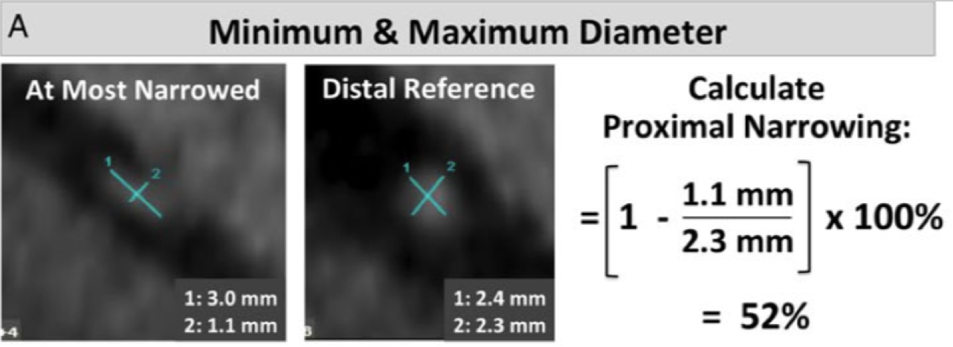

- Proximal vessel morphology: categorize proximal vessel morphology as: (i) normal, (ii) ‘oval (<50%), and (iii) ‘slit-like’ narrowing (≥50% reduction in minimum diameter in the absence of coronary artery disease). Figure 2. ^{2,3}

Figure 2: Proximal Vessel Morphology
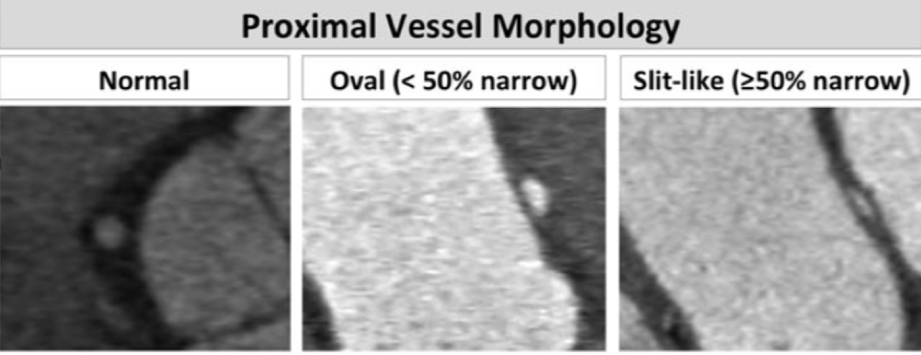

- Length of narrowing: centerline length of vessel narrowing extending from the most proximal segment to the normal caliber distal reference (Firgure 3).¹

Figure 3: Length of Narrowing
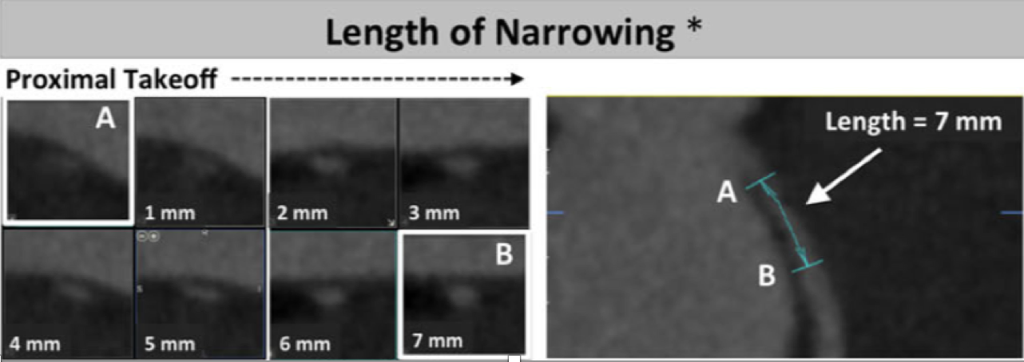

- Acute angle: defined as the presence or absence of acute angle take-off <45° between (a) the plane formed by the ostium centre to a point 5 mm along the vessel centerline, and (b) a plane tangent to the aorta in multiplanar axial reconstruction at the level of the ostium (Figure 4), ^{3,4}
- Intramural course: defined as (i) presenct, (ii) absent, or (iii) indeterminate (Figure 4).¹
- Vessel take-off level: categorized as at/above or below the aortic valve commissure (Figure 4).¹

Figure 4: Course, Angle and Takeoff level of coronary arteries
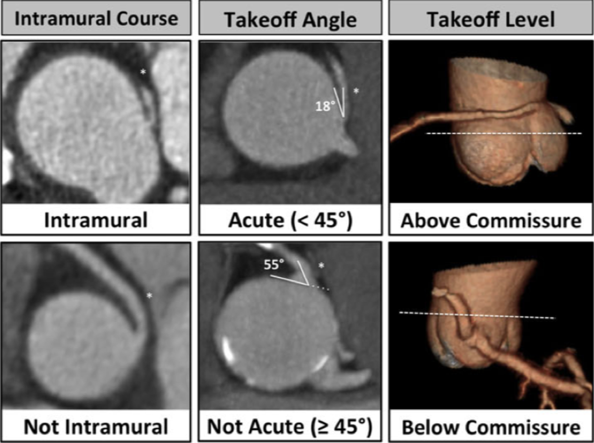

- Ostia type: defined as (i) separate, (ii) shared, or (iii) branch vessel (Figure 5).¹

Figure 5: Type and branching of coronary ostias
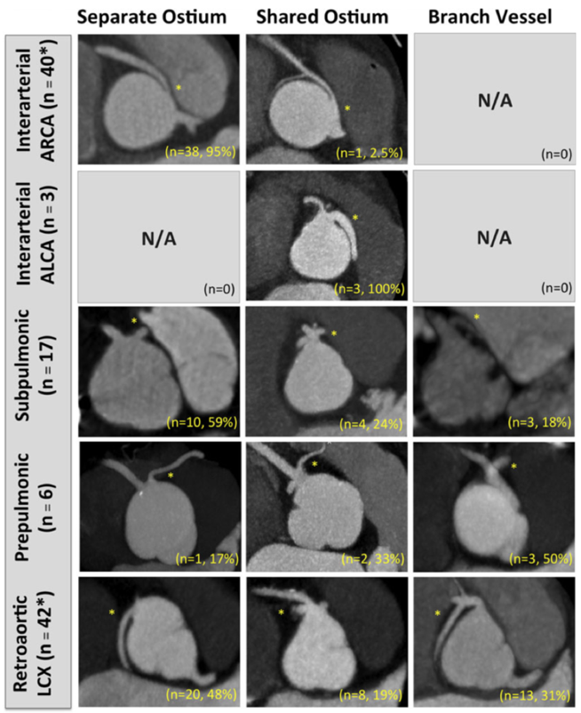

- Coronary pattern will be described using the classification of Yacoub and Radley-Smith.^{5,}

Right ventricle outflow tract, pulmonary annulus, main pulmonary artery and pulmonary arteries will be also assessed with a measurement of the narrowest diameter at each level in views obtained orthogonal to the centerline of the corresponding vessel. ₋All diameters will be measured perpendicular to the centreline of the pulmonary artery, during end-diastole

Finally, the maximal diameters at level of aortic annulus, sinus of Valsalva, sino-tubular junction and the ascending and descending aorta (next to the left pulmonary artery) will be measured in orthogonal views of the ascending aorta.
- All diameters will be measured perpendicular to the centreline of the aorta
- All aortic diameters are measured with the inner edge to inner edge convention, during end-diastole
- The dimeter of the sinus of Valsalva will be the maximal diameters among the 3 diameters obtained by measurements sinus to sinus.
- Ascending and descending aorta will be measured in the same plane than the pulmonary artery bifurcation.

Results / Report
Responsibility | Procedure
PI of each center/ Corelab | Analyse data locally and in core lab
The following data should be collected and reported:
These measurements must be reported for LCA (if separate ostia: for LAD and CX) and RCA
- CA anatomy type
- Minimum / maximum diameter of proximal coronary arteries
- Proximal narrowing (see text for details)
- Proximal vessel morphology: Normal, oval, slit-like
- Length of narrowing
- Takeoff angle
- Takeoff level

- Neo-Aortic diameters
  - Aortic root level
  - Ascending aorta
  - Aortic arch
- Diameter of proximal branch pulmonary arteries

References

Anomalous origin of the coronary artery arising from the opposite sinus: prevalence and outcomes in patients undergoing coronary CTA. Cheezum MK; Ghoshhajia B; Bittencourt AS et al. Eur Heart J Cardiovasc Imaging. 2017; 18(2):224-235 ² Prevalence and characteristics of coronary anomalies originating from the opposite sinus of Valsalva in 8522 patients referred for coronary CTA. Opolski MP, Pregowski J, Kruk M, et al. Am J Cardiol 2013;111:1361-1367 ³ Anatomic characteristics and outcome of adults with coronary arteries arising from an anomalous location detected with coronary CTA. Nasis A, Machado C, Camerin JD, et al. Int J Cardiovasc Imaging 2015;31:181-189 ⁴ Acute takeoffs of the coronary arteries along the aortic wall and congenital coronary ostial valve-like ridges: association with sudden death. Virmani R, Chun PK, Goldstein RE, et al. J Am Coll Cardiol 1984;3:766-771 ⁵Anatomy of the coronary arteries in transposition of the great arteries and methods for their transfer in anatomical correction M.H. Yacoub, R. Radley-Smith. Thorax, 33 (1978), pp. 418-424

